**SPRINT 4**

|  |  |
| --- | --- |
| Team ID | PNT2022TMID26870 |
| Project Name | Project – Smart Farmer-IoT Enabled smart Farming Application |
| Date | 18 November 22 |

**CONFIGURATIONOFNODE-REDTOSENDCOMMANDSTOIBMCLOUD**

Here we add two buttons in UI1-

>for MOTOR ON

2->For MOTOR OFF

We used a function node to analyse the data received and assign command to each

Number . the java script code for the analyse is:

If msg.payload={

    "temperature":global.get('temp'),

    "humidity": global.get('hum'),

    "moisture": global.get('moist')

}

return msg;

**in condition on off**

{"command ":"motoron"}

{"command ":"motoroff"}

**Adjusting User Interface**

In order to display the par send JSON data a Node-Red dashboard is created

Here we are using Gauges, text and button nodes to display in the UI and helps to monitor the parameter send control the farm equipment.

Below images we started to create the flow1

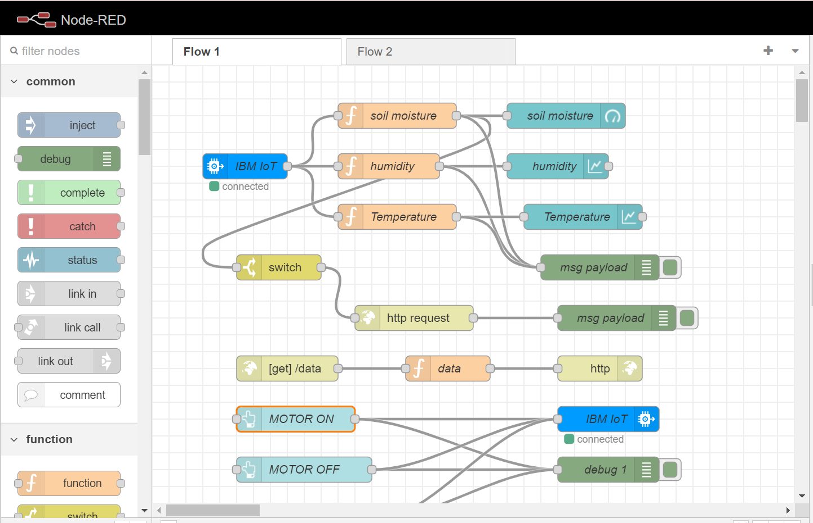

**COMPLETE PROGRAM FLOW:**

